# SQL Reports - Travelogy

1. **Report: High-Value Customers**

* **Description:** Lists customers who have spent over $1500, highlighting their total expenditure.
* **Business Purpose & Benefit:** Identifies the most valuable customers, enabling targeted marketing and personalized service offers.
* **Use in Business Metric:** Key for customer segmentation, relationship management, and revenue forecasting.

1. **Report: Total Revenue per Service Type**

* **Description:** Total revenue generated by each service type.
* **Business Purpose & Benefit:** Prioritizes business focus by showing the financial contribution of each service.
* **Use in Business Metric:** Acts as a crucial metric for financial planning and business health evaluation.

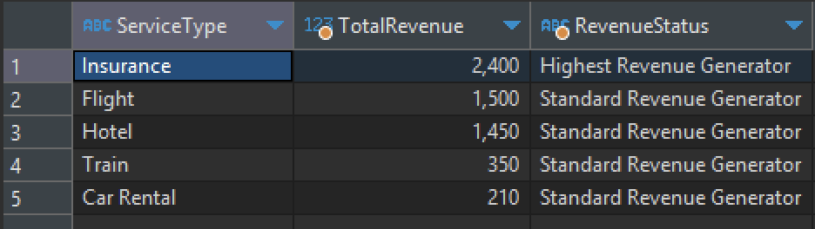

1. **Report: Service Performance Indicators**

* **Description:** Shows the minimum and maximum amounts paid for each service type and categorizes their value.
* **Business Purpose & Benefit:** Assists in recognizing service types that are either underperforming or overperforming in revenue generation.
* **Use in Business Metric:** Informs service pricing strategy and aids in adjusting focus on profitable services.A screenshot of a graph

  Description automatically generated

1. **Report: Feedback Analysis**

* **Description:** Analyzes feedback comments for sentiment based on the presence of specific keywords.
* **Business Purpose & Benefit:** Provides insights into customer satisfaction and areas for service improvement.
* **Use in Business Metric:** Important for quality assurance, service development, and maintaining high customer satisfaction.

1. **Report: Booking Frequency by Service Type**

* **Description:** Categorizes the booking frequency for each service type into 'High', 'Medium', and 'Low' based on the number of bookings.
* **Business Purpose & Benefit:** This report helps to identify which services are most and least frequently booked, allowing for targeted improvements and marketing efforts.
* **Use in Business Metric:** Booking frequency categories serve as an indicator of customer demand and service popularity, which can influence strategic decisions such as resource allocation, service promotion, and performance evaluation.

